Hair collection – MTN-025 (HOPE)

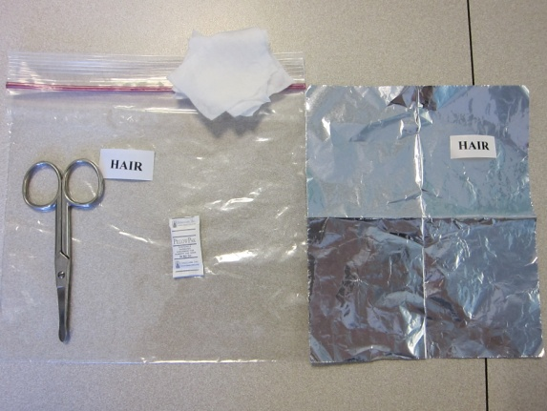
Materials required: Scissors, piece of tin foil, patient labels (2), ziplock bag, alcohol swabs, and desiccant pellet
Suggest making these “hair kits” ahead of time

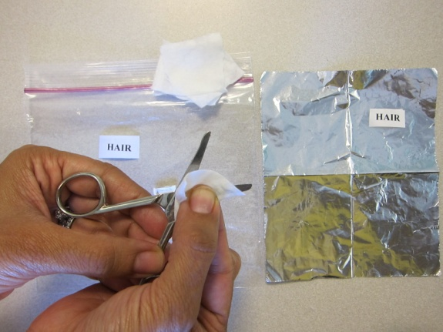
Step 1: Clean the blades of a pair of scissors with an alcohol pad and allow blades to completely dry
Clean off blades of scissors between patients

Step 2: Lift up the top layer of hair from the occipital region of the scalp. Isolate a small thatch of hair (~100 fibers of hair) from underneath this top layer
Can use hair clip to keep top layer of hair away if easier

Step 3: Cut the small hair sample as close to the scalp as possible

STRAIGHT HAIR
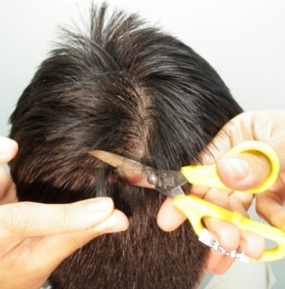

CURLY HAIR

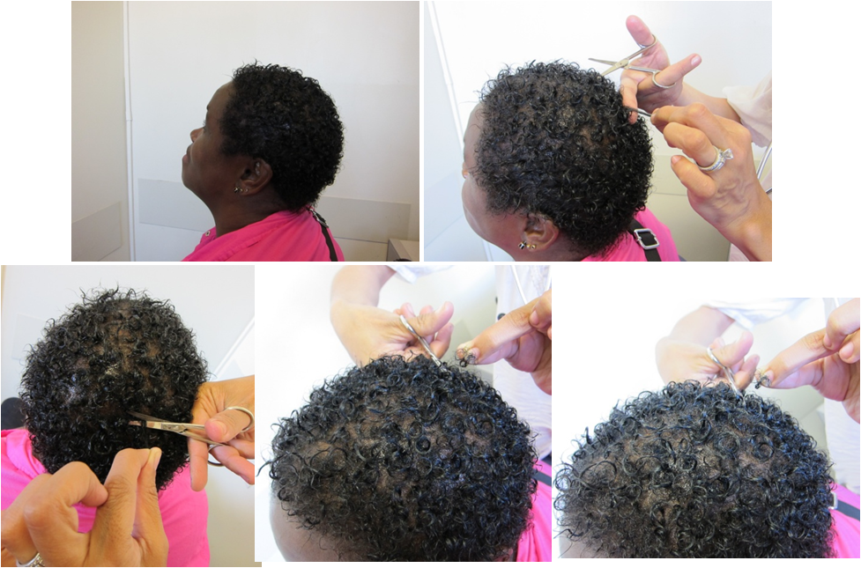

SHORT HAIR
Can let hair fall directly into piece of tin foil when very short/cropped (no need to label end since too short)

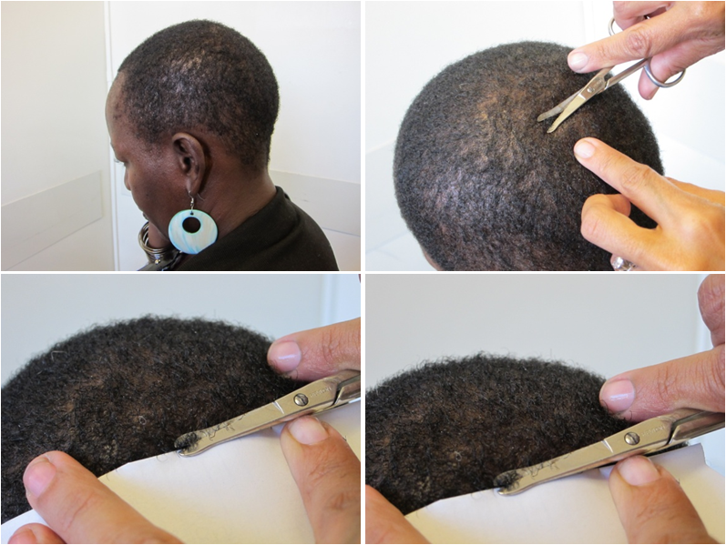

BRAIDED HAIR
Cut hair thatch from in-between braids or dread locks

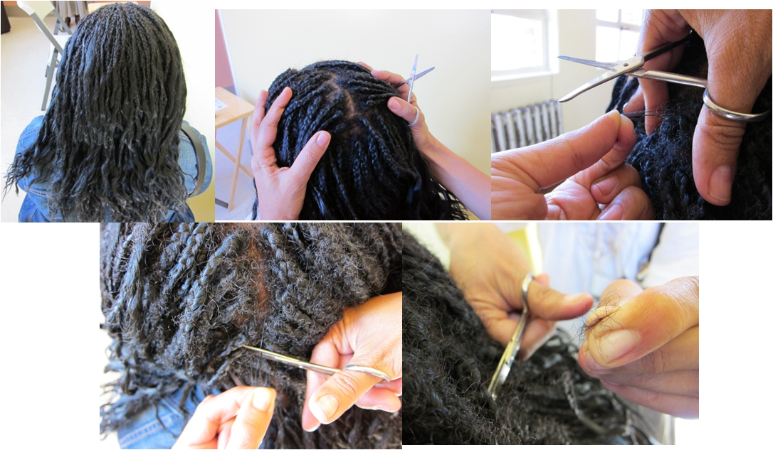
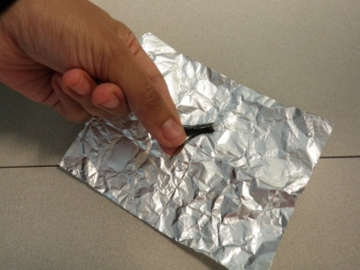

Step 4: Keep your fingers on the part of the hair that was FURTHEST away from the scalp and put the hair sample down on an unfolded piece of tin foil

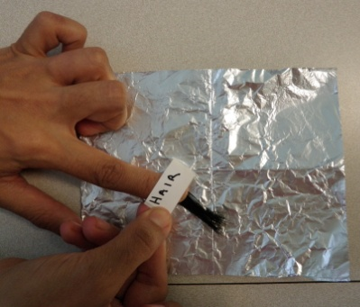
Step 5: Put a thin label over the end of the hair sample that was FURTHEST away from the scalp
If hair very short just let it fall into the piece of tin foil and no need to label the distal end

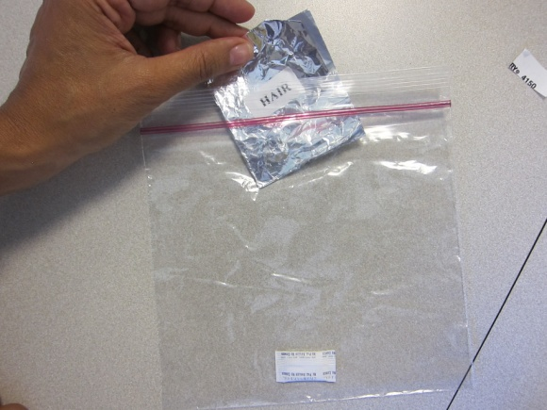
Step 6: Refold the foil over to completely enclose the hair and place a study ID label on the folded piece of foil

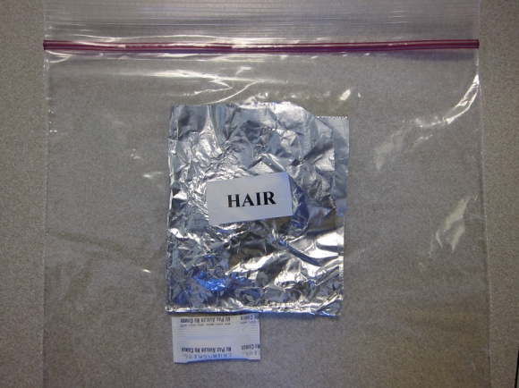

Step 7: Place the folded piece of foil inside the plastic (e.g. Ziplock®) bag (desiccant pellet in the bag is optional) and seal the bag;

Hair samples should be kept at room temperature and in a dark place at each site prior to batch shipment (without biohazardous restrictions) to our hair laboratory at UCSF.

Questions: Contact Monica Gandhi at monica.gandhi@ucsf.edu with Edward Livant Copied at livantew@upmc.edu

